# Diabetes Classification Results using AdaBoost

## Classification Report:

precision recall f1-score support  
  
 0 0.75 0.70 0.72 149  
 1 0.72 0.77 0.74 151  
  
 accuracy 0.73 300  
 macro avg 0.73 0.73 0.73 300  
weighted avg 0.73 0.73 0.73 300

## ROC AUC Score:

ROC AUC Score (AdaBoost): 0.8307035868260813

## ROC Curve:

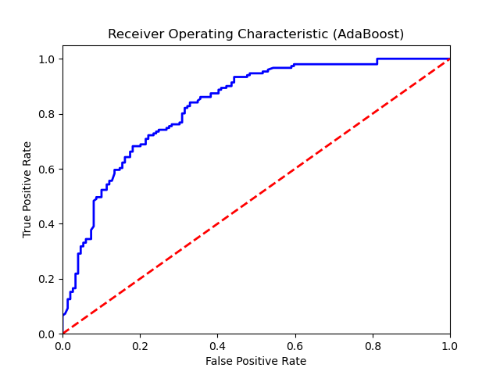

## Confusion Matrix:

True Negatives: 104

False Positives: 45

False Negatives: 35

True Positives: 116

## Confusion Matrix Plot:

